

FACULTY OF TECHNOLOGY AND ENGINEERING
DEVANG PATEL INSTITUTE OF ADVANCED TECHNOLOGY AND RESEARCH

DEPARTMENT OF INFORMATION TECHNOLOGY

A.Y 2026-27 Semester-3

LAB MANUAL

CSUC201: Fundamentals of Data Structure and Algorithms



Practical 6
Practical AIM:
To implement stack using array and linked list, and apply stack-based logic to expression conversion, evaluation, and bracket validation problems.
Practical 6.1
Problem definition:
A cafeteria stacks clean trays on a fixed-size counter. New trays are always placed on top, and customers always take from the top. The counter can hold at most n trays at a time — if it is full, no more trays can be added, and if it is empty, no tray can be taken. Given a sequence of place and take operations, implement this fixed-capacity tray stack and print the current top tray after each operation. Report an error if a place or take operation cannot be performed.
Describe how your solution tracks whether the stack is full or empty. What are the exact conditions you check before a push and before a pop, and what does your program do when those conditions fail?
Problem faced:
I faced difficulty while handling the full and empty conditions of the stack during push and pop operations.
Solution:
I used a top variable to track the top element of the stack. Before push, I checked whether top == n - 1 to detect a full stack. Before pop, I checked whether top == -1 to detect an empty stack. If either condition was true, I displayed an error message; otherwise, the operation was performed.
Output:
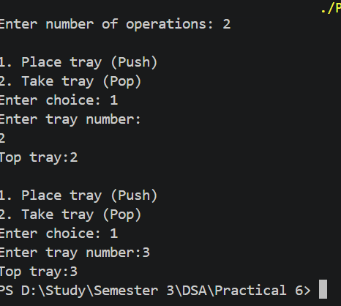
Practical 6.2
Problem definition:
A web browser keeps track of pages visited so that the back button always returns to the most recently visited page. Unlike a fixed counter, the browser has no hard limit on how many pages it can remember — it grows as the user visits more pages and shrinks as they press back. Given a sequence of visit and back operations, implement this unlimited page history and print the current page after each operation.
Describe how your solution differs from Problem 1 in how it handles memory. What happens in your solution when the user presses back on the very first page with no history left?
Problem faced:
I faced difficulty while managing the browser history dynamically and handling the back operation when no previous page was available.
Solution:
I used a linked list to store the visited pages, which allows the history to grow dynamically without a fixed size. For the back operation, I moved the top pointer to the previous page and deleted the current node. If there was no page left, I displayed a message that no history was available.
Output:
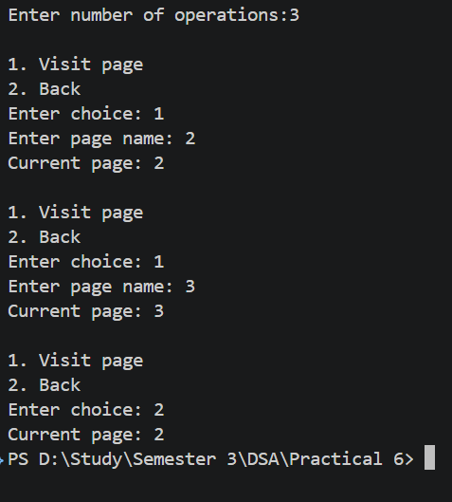
Practical 6.3
Problem definition:
A calculator application receives arithmetic expressions typed by users in the usual way — numbers and operators written in between, with brackets to control priority (e.g. 3 + 4 * 2 or (3 + 4) * 2). Internally the calculator needs to convert each expression into a form where operators appear after their operands, so it can evaluate them without needing to re-read brackets. Given an infix expression, convert it to the equivalent postfix form and print the result.
Describe the role the stack plays in your conversion. What does your solution do when it encounters a closing bracket, and what happens to the operators that were waiting on the stack at that point?
Problem faced:
I faced difficulty in handling operator precedence and brackets while converting the infix expression into postfix form.
Solution:
I used a stack to temporarily store operators and brackets. I checked operator precedence and popped operators when required. For a closing bracket, I popped operators until the opening bracket was found.
Output:
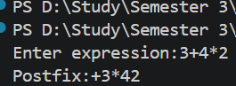

Key Questions
1. [Problem 1] A circular array is one way to reuse freed slots without shifting all elements. Without implementing it, explain what change would need to be made to your front and rear pointer logic to make the array behave circularly, and what new condition would indicate a full array.
ANS:
In a circular array, the front and rear pointers move back to the beginning after reaching the last position. This can be done using (index + 1) % n. The array is full when the next position of rear becomes front, i.e. (rear + 1) % n == front.
2. [Problem 2] Your linked list stack has no fixed capacity limit. But in practice, can it still run out of space? What determines the actual limit, and why is that limit invisible in your code?
ANS:
Yes, a linked list stack can still run out of space. Its actual limit depends on the available memory (RAM/heap) of the system. This limit is not fixed in the code because nodes are created dynamically as needed until the system cannot allocate more memory.
3. [Problem 3] operator precedence determines the order in which operators are placed into the output. Without tracing any expression, explain what would go wrong in your output if your solution treated all operators as having equal precedence.
ANS:
If all operators are treated as having equal precedence, the postfix expression may place operators in the wrong order. For example, multiplication should be performed before addition, but treating them equally can produce an incorrect postfix expression and therefore an incorrect result.
Github Link:
https://github.com/dhanvi-219/FDSA/tree/main/Practical%206

